 | Hong Kong Housing Society
 | Electrical and Mechanical Services Department
 | Hospital Authority
 | Leisure and Cultural Services Department
 | Urban Renewal Authority
 | MTR Corporation Limited
 | PCCW
 | Jones Lang LaSalle
 | ISS East Point Facility Services Ltd
 | Knight Frank Petty Ltd
 | Well Born Real Estate Management Limited
 | Philippine Consulate General, HKSAR
 | The Methodist Church, Hong Kong
 | St. James Settlement
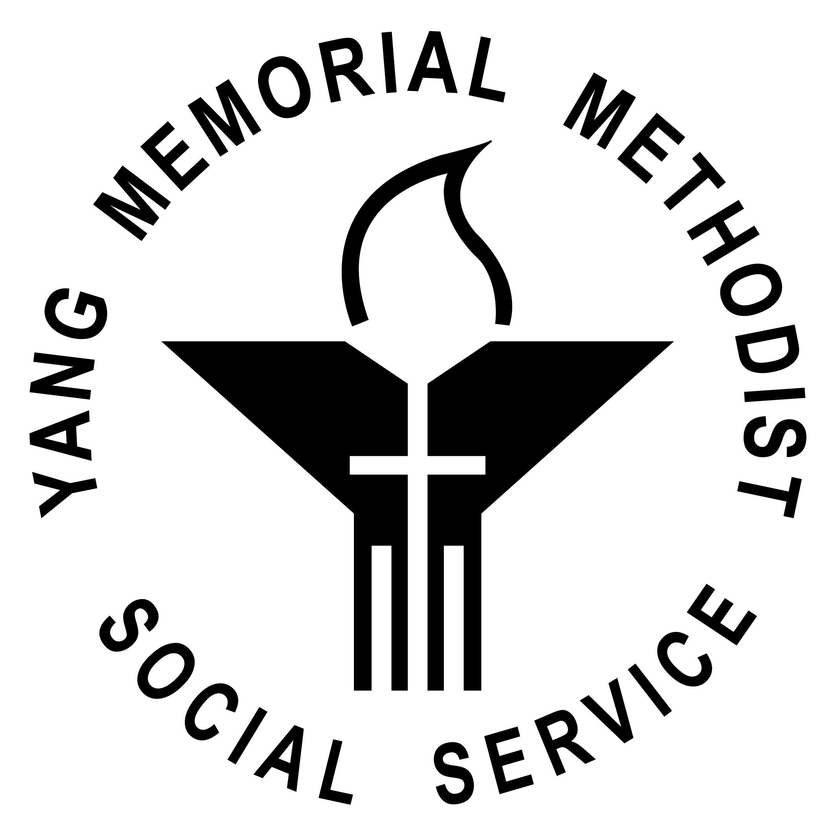 | Yang Memorial Methodist Social Service
 | The University of Hong Kong
 | HK University of Science &Technology
 | The Hong Kong Polytechnic University
 | Lingnan University
 | Construction Industry Council Training Academy

Recommendation Letter
顧客推薦信
